Superset ID: 6125132
Name : P. Vinay Kumar
Week : 5
Creating Microservices for account and loan
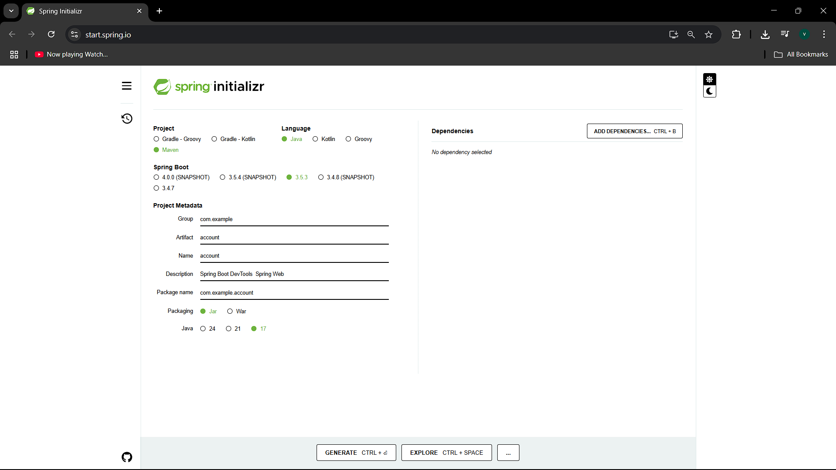

Account Project:
📄 AccountApplication.java
package com.cognizant.account;

import org.springframework.boot.SpringApplication;
import org.springframework.boot.autoconfigure.SpringBootApplication;

@SpringBootApplication
public class AccountApplication {
public static void main(String[] args) {
SpringApplication.run(AccountApplication.class, args);
}
}
📄 AccountController.java
package com.cognizant.account;

import org.springframework.web.bind.annotation.*;

@RestController
@RequestMapping("/accounts")
public class AccountController {

@GetMapping("/{number}")
public Account getAccount(@PathVariable String number) {
return new Account("00987987973432", "savings", 234343);
}

static class Account {
public String number;
public String type;
public int balance;

public Account(String number, String type, int balance) {
this.number = number;
this.type = type;
this.balance = balance;
}
}
}
{
"number": "H00987987972342",
"type": "car",
"loan": 400000,
"emi": 3258,
"tenure": 18
}

Output:

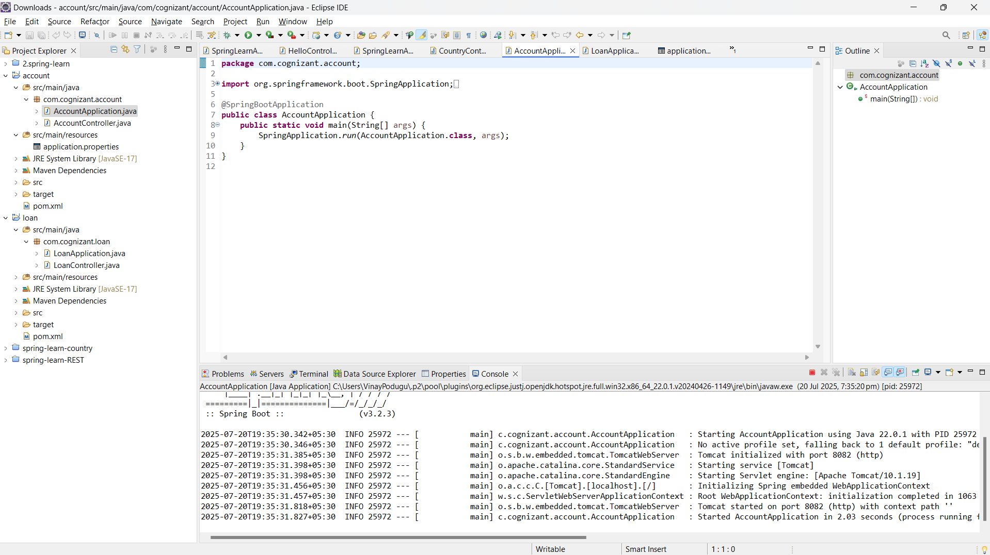

Loan Project :
LoanApplication.java
package com.cognizant.loan;

import org.springframework.boot.SpringApplication;
import org.springframework.boot.autoconfigure.SpringBootApplication;

@SpringBootApplication
public class LoanApplication {
public static void main(String[] args) {
SpringApplication.run(LoanApplication.class, args);
}
}

LoanController.java
package com.cognizant.loan;

import org.springframework.web.bind.annotation.*;

@RestController
@RequestMapping("/loans")
public class LoanController {

@GetMapping("/{number}")
public Loan getLoan(@PathVariable String number) {
return new Loan("H00987987972342", "car", 400000, 3258, 18);
}

static class Loan {
public String number;
public String type;
public int loan;
public int emi;
public int tenure;

public Loan(String number, String type, int loan, int emi, int tenure) {
this.number = number;
this.type = type;
this.loan = loan;
this.emi = emi;
this.tenure = tenure;
}
}
}
Expected Output:
{
"number": "H00987987972342",
"type": "car",
"loan": 400000,
"emi": 3258,
"tenure": 18
}

Output:
